Project Title
Industrial Spur Gearbox Assembly Design and Detailing Using SolidWorks.

Project Overview
Designed and developed a complete Spur Gearbox Assembly in SolidWorks, including 3D part modelling, assembly creation, exploded view generation, engineering drawings, and manufacturing-ready documentation. The gearbox was created for power transmission applications requiring reliable speed reduction and torque multiplication.
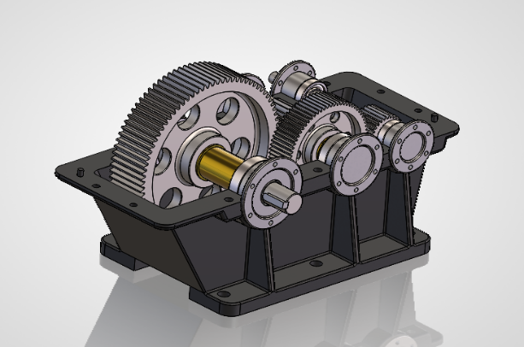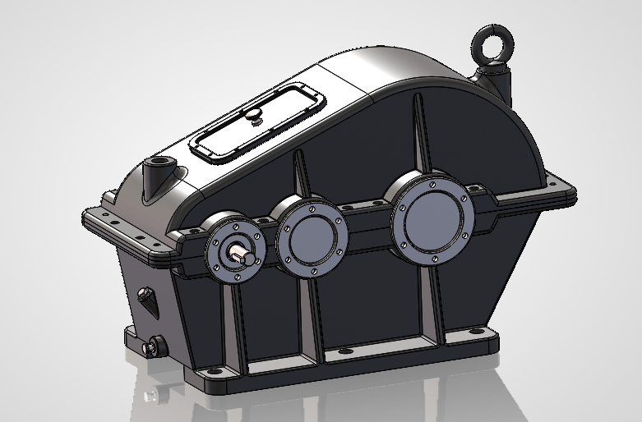
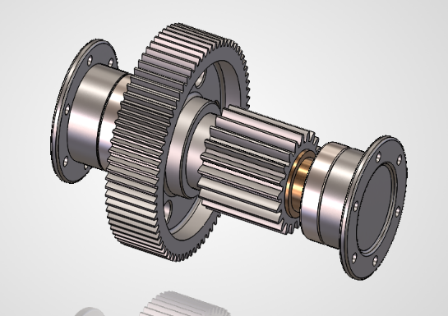
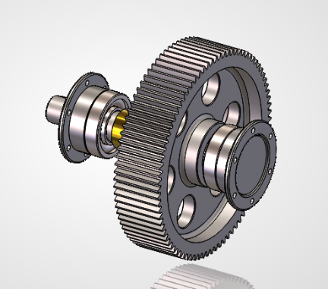
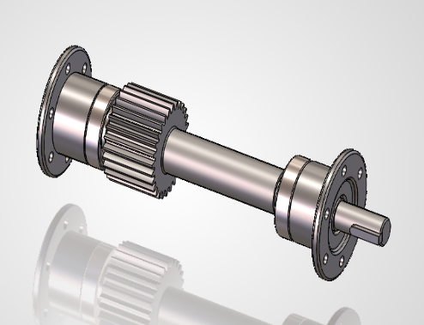

Project Objectives
- Design a robust gearbox housing assembly.
- Develop gear and shaft arrangements for power transmission.
- Create detailed manufacturing drawings.
- Generate exploded assembly views and BOM structure.
- Apply GD&T and engineering drafting standards.
- Prepare assembly documentation for production.
Software Used
- SolidWorks 2026
- AutoCAD
- Microsoft Excel (BOM Documentation)
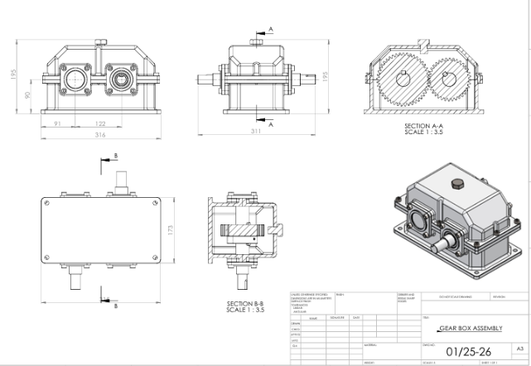
Key Components Designed
Housing Components
- Upper Housing Cover
- Lower Housing Base
- Blunking Plug
Power Transmission Components
- Input Shaft
- Output Shaft
- Spur Gears
- Keys
Support Components
- Bearing Cover
- Bearings
- Rings
- Eye Bolt
Manufacturing Drawing & BOM
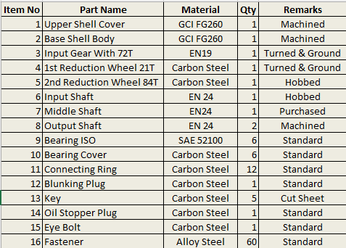
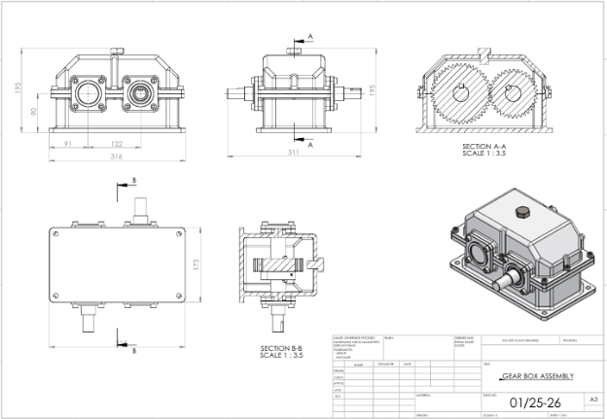

Project Outcome
Successfully developed a complete gearbox assembly with:
- 100% parametric 3D model.
- Detailed engineering drawings.
- Exploded assembly documentation.
- Manufacturing-ready design package.
- Professional CAD documentation standards.

